MBEYA UNIVERSITY OF SCIENCE AND TECHNOLOGY
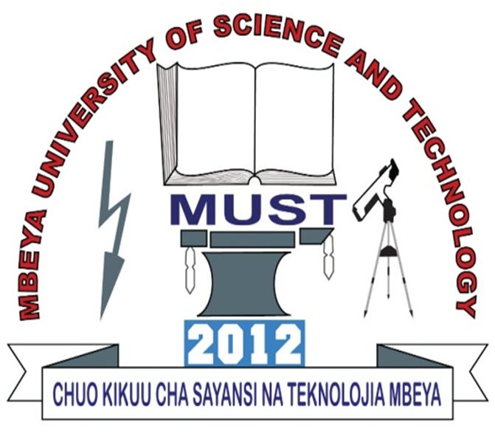
COLLEGE: COLLEGE OF INFORMATION AND COMMMUNICATION TECHNOLOGY
DEPARTMENT: DEPARTMENT OF ELECTRONICS AND TELECOMMNUNICATION ENGINEERING
PROGRAMME: BACHELOR OF ENGINEERING IN TELECOMMUNICATION SYSTEM
INSTRUCTOR: DR.MSANGI S.
STUDENT’S NAME: JACKLINE STEPHEN NDABILA
REGISTRATION NUMBER: 21100934340004
LEVEL: UQF8 FOURTH YESR
QUESTION NO 25: Business ethics (concepts, sources, features, aspects of ethics, advantage and disadvantages, how entrepreneur improve ethical standards, code of ethics for ICT business, ethical principle)

BUSINESS ETHICS- refers moral and principles that governs the behavior or conduct of a business. It involves making decisions that align with values and expectations, ensuring fairness, transparency, and accountability. Ethical conduct builds trust, enhances reputation, and attracts responsible investors and customers.
CONCEPTS OF BUSINESS ETHICS
- Integrity- Honesty in all business dealings.
- Fairness- Equal treatment of all stakeholders.
- Accountability- Taking responsibility for decisions and actions.
- Transparency- Open and honest communication.
- Corporate Social Responsibility (CSR)-Business obligation to benefit society.
SOURCES OF BUSINESS ETHICS
- Religion- Many ethical principles are rooted in religious teachings (e.g., honesty, charity).
- Culture and Traditions- Societal norms shape business conduct.
- Law- Legal standards often reflect ethical norms.
- Philosophy: Ethical theories like utilitarianism, deontology.
- Professional Codes of Conduct- Industry-specific standards.
- Organization's Values- Mission, vision, and internal policies.
- Education- Ethical training in schools and professional courses.
FEATURES OF BUSINESS ETHICS:
- Business ethics is a code of conduct it tells what to do and not to do for the sake of the society
- Base on moral and social value include self-control , consumer protection, service to society ,fair treatment to the social groups
- Provide basic framework that is it gives social, cultural, economic, legal limit of business
- Business ethics are voluntary they be like self-disciplined and not enforced by laws
- Business ethics lacks universal acceptance they vary from company to company.
APPROACHES OF BUSINESS ETHICS
- Utilitarianism- This approach focuses on maximizing overall well-being and minimizing harm for the greatest number of people. In business, this might mean choosing a course of action that benefits the most stakeholders, even if it means some individuals may be negatively impacted.
- Justice Theory- This approach focuses on ensuring fairness and equity in business practices. It suggests that businesses should treat all stakeholders fairly, regardless of their position or status.
- Rights Theory- This approach emphasizes the protection of fundamental human rights in business practices. It suggests that individuals have inherent rights that should be respected and upheld, such as the right to privacy, fair treatment, and freedom from discrimination.
- Deontology- This approach emphasizes the importance of adhering to moral rules and duties, regardless of the consequences. It suggests that certain actions are inherently right or wrong, and that businesses should always act in accordance with moral principles, even if it means sacrificing short-term profits.
- Principle Ethics- This approach emphasizes the development of moral character and good habits in business leaders and employees. It suggests that ethical decision-making is often rooted in principles like honesty, integrity, fairness, and compassion.

TYPES OF BUSINESS ETHICS
- Individual Ethics- Refers to the personal moral principles and values that guide the behavior of individuals within a business.
- Organizational Ethics- Involves the values, norms, and ethical climate established by an organization to guide the behavior of its members.
- Social Ethics- Concerns the responsibilities of businesses towards society, including philanthropy, community development, and social justice.
- Professional Ethics- Refers to the ethical standards and codes of conduct specific to certain professions or industries.
- Environmental Ethics- Focuses on the moral obligations of businesses to protect and preserve the environment.

ASPECTS OF ETHICS IN BUSINESS
- Personal Ethics- Individual values of employees or entrepreneurs.
- Corporate Ethics- Organizational standards and policies.
- Professional Ethics- Conduct standards for specific professions (e.g., IT, law).
- International Ethics- Business conduct across borders, respecting global norms.
- Environmental Ethics- Responsibilities toward the environment and sustainability.

ADVANTAGES OF BUSINESS ETHICS
- Builds trust and a good reputation.
- Attracts customers, investors, and talent.
- Enhances employee satisfaction and retention.
- Encourages long-term growth and sustainability.
- Better financial performance as they often experience higher revenues and profits.
- Provides a framework for resolving dilemmas.
DISADVANTAGES OF BUSINESS ETHICS
- Implementation Costs as they require resources for training, communication and update.

Can create conflicts between ethics and profit motives.

May limit profit maximization.
CODE OF ETHICS FOR ICT BUSINESS
- Privacy-Protecting user and customer data.
- Security- Ensuring systems are safe from unauthorized access.
- Transparency- Clear terms of service and data usage policies.
- Intellectual Property- Respecting copyrights and software licenses.
- Social Responsibility- Designing technology that benefits society.
- Accessibility- Ensuring technology is inclusive and non-discriminatory.
ETHICAL PRINCIPLES FOR ICT BUSINESS
- Integrity- Being honest, transparent, and trustworthy in all business dealings.
- Respect- Treating all individuals with dignity, fairness, and courtesy.
- Responsibility- Acknowledging and fulfilling obligations to stakeholders, society, and the environment.
- Fairness- Ensuring fairness and equity in all decisions and actions.
- Accountability- Taking responsibility for one’s actions and their consequences.
- Compliance- Adhering to laws, regulations, and industry standards.
- Sustainability- Considering the long-term impact of decisions on people, planet, and profits.
RISK ND THREATS INVOLVED IN BUSINESS ETHICS
- Reputational risk- Unethical behavior can damage a company's image. Example is mistreatment of workers
- Legal risk-Violating ethical standards can lead to breaking laws and regulations. Examples like Fraud, bribery, which can lead to lawsuits and fines
- Financial Losses -Ethical misconduct, such as corruption or insider trading, can lead to financial instability and loss of investor confidence.
- Employee Morale Issues -Unethical workplace practices, such as discrimination or unfair treatment, can reduce employee motivation and productivity
- Cybersecurity Threats-Ethical risks related to data privacy and security breaches can expose sensitive customer and business information.
- Stakeholder Distrust - If a company fails to uphold ethical standards, it may lose the trust of investors, customers, and partners, affecting long-term success.
HOW ENTREPRENEURS IMPROVE ETHICAL STANDARDS
- Lead by Example- Demonstrate ethical behavior in decision-making.
- Establish a Code of Ethics-Create and enforce formal ethical guidelines.
- Employee Training- Educate staff on ethical issues and responses.
- Reporting- Protect and encourage reporting of unethical behavior.
- Implement Fair Policies-Treat customers, employees, and suppliers fairly.
- Monitor Compliance: Regular audits and reviews of ethical performance.

